Subsidiary Mathematics
SENIOR FIVE term 3
TOPIC 1/3: Scatter Diagrams and Correlations
Regression and correlations
Correlations are the measure of how two or more variables are related to one another.
An independent variable is one which is not affected by the other (dependent variable) e.g. age is an independent variable while height of an individual is a dependent variable.
Regression is a statistical technique that relates a dependent variable to one or more independent variables. A regression model is able to show whether changes observed in the dependent variable are associated with changes in one or more of the independent variables by determining a best-fit line and seeing how the data is dispersed around this line.
Scatter diagrams/graphs
The scatter diagram /graphs are plots of pairs of numerical data, with one variable on each axis, to look for a relationship between them
Line of best fit
It is a straight line that goes roughly through the middle of all points plotted on a scatter diagram/graph.
It is used to express a relationship in a scatter plot of different data points.
The closer the points to the line of the best fit, the stronger the correlation
Note that the line of the best fit passes through the mean of x and mean of y. these should be calculated to guide you as you draw the line of the best fit but should not be plotted.

Positive correlation occurs when both the value of the variable increase or decrease
y

x

Negative or inverse correlation occurs when the increase in one of the variables cause a decrease in another.

y

x

Zero or correlation occurs when the increase or decrease in one of the variables does not cause any change in another.
y

x

Example 1
- The table below shows the marks of eight students in the mid-term test and end of term test in Economics.
Mid-term tests (x) | 99 | 71 | 50 | 67 | 77 | 81 | 96 | 72
End of term test (y) | 99 | 55 | 35 | 60 | 75 | 70 | 99 | 50
    - Draw a scatter diagram for the data
    - On the same diagram draw a line of the best fit
Solution
Note that the line of the best fit passes through the mean of x and mean of y. these should be calculated to guide you as you draw the line of the best fit but should not be plotted. On the plot below (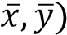 are encircled in red

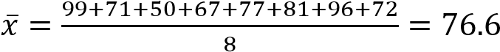
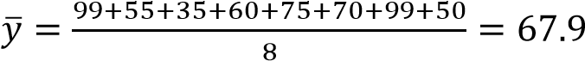
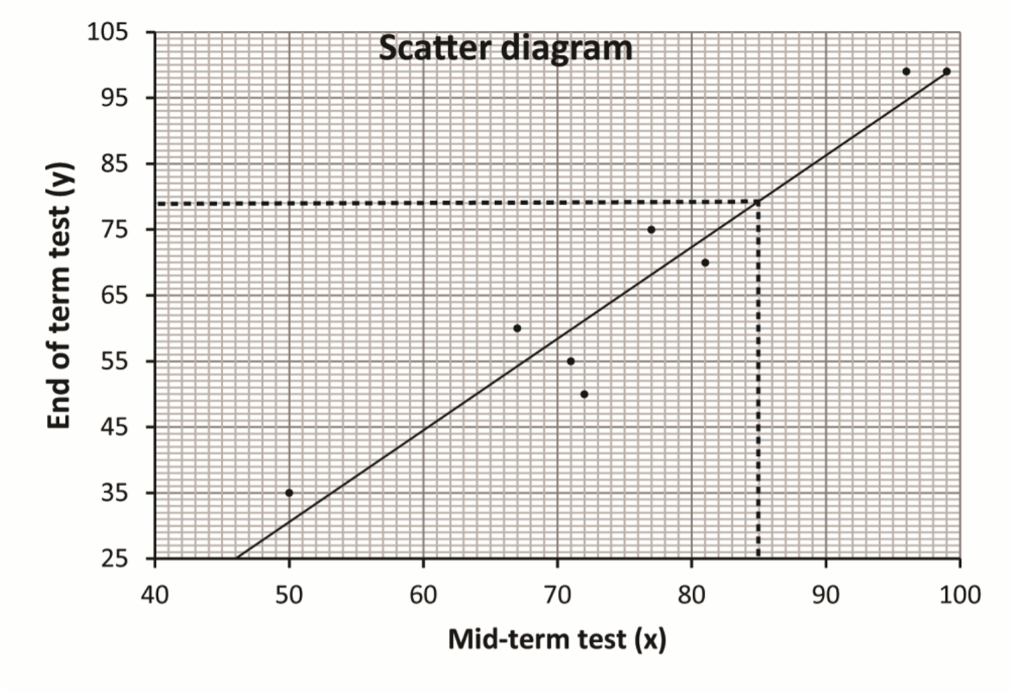

(
iii
)

Use the line of the best fit to find the value of y when x
–

85. (08
marks
)

78
(iv) Comment on the results
There is a positive correlation the two tests.

- The table shows scores by 10 students (A to J) in Physics and Mathematics tests
Students | A | B | C | D | E | F | G | H | I | J
Mathematics (x) | 28 | 20 | 40 | 28 | 21 | 31 | 36 | 29 | 33 | 24
Physics (y) | 30 | 20 | 40 | 28 | 22 | 35 | 35 | 27 | 31 | 23
  - (i) Plot a scatter diagram for the given data.
    - Draw a line of the best fit on the scatter diagram
Solution
Note that the line of the best fit passes through the mean of x and the mean of y; these should be calculated to guide you when drawing a line of the best fit but should not be plotted

On the graph below the point 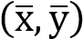 are encircled by red
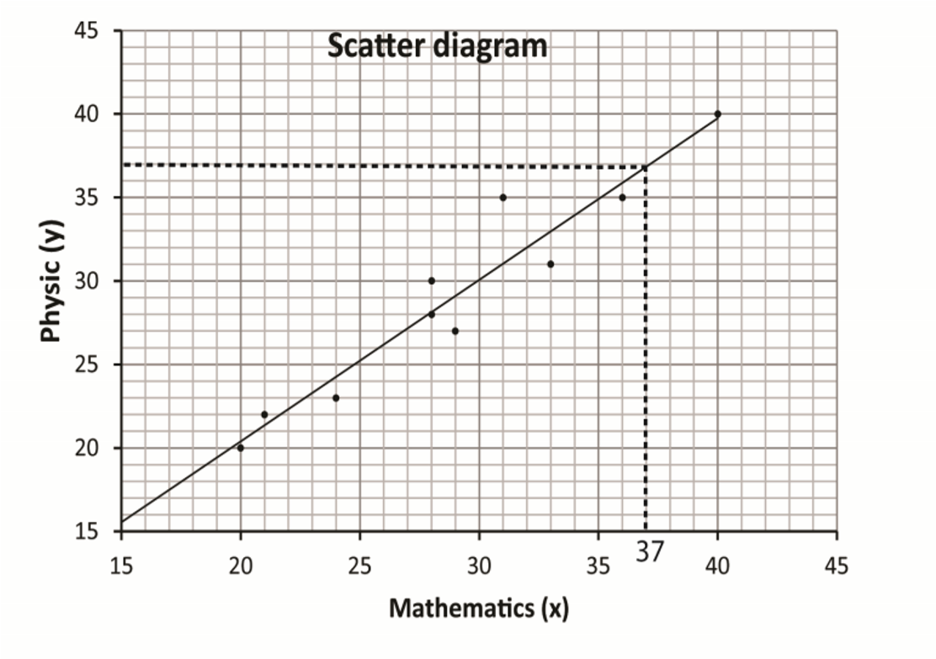

    - Estimate the score in Mathematics for a student who scores 37 in physics. (08marks)
37
- The table below shows the heights to nearest cm and the masses to the nearest kg of 10 students, A to J.
Student | A | B | C | D | E | F | G | H | I | J
Mass (kg) (x) | 53 | 68 | 57 | 52 | 66 | 64 | 63 | 58 | 57 | 68
Height (cm)(y) | 148 | 172 | 156 | 139 | 163 | 158 | 168 | 151 | 144 | 170
  - (i) Plot the given data on a scatter diagram
      - Draw a line of best fit on the scatter diagram

Solution
Note that the line of the best fit passes through the mean mass ( ̅) and mean of height ( ̅) and these should be calculated to guide you when drawing the line of the best fit
The point 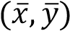 is shown on the graph below by a red circle but should not be plotted
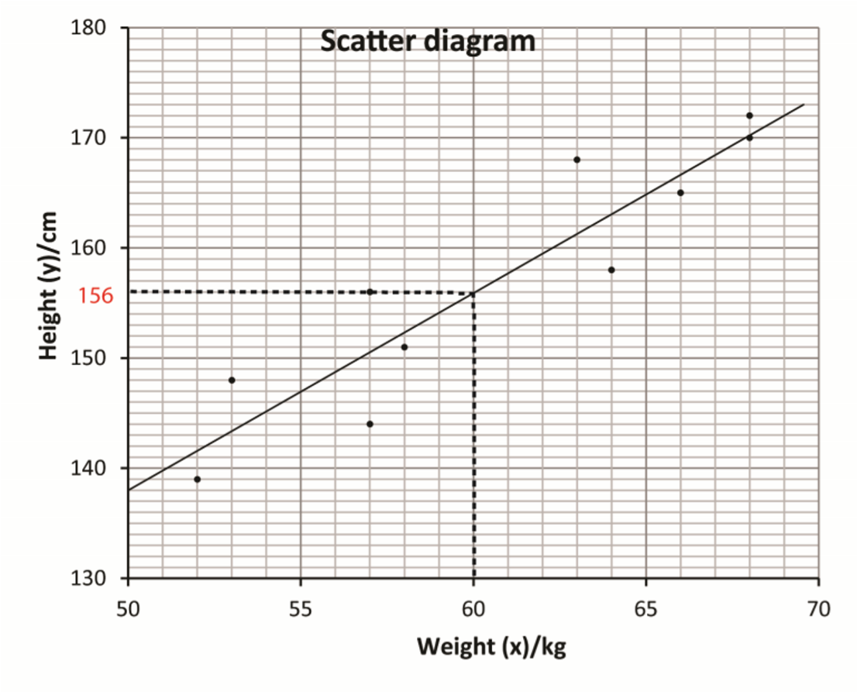

      - Estimate the height of a student whose mass is 60 kg. (08marks)
156 (cm)
- The table below shows marks obtained in sub-Math and Physics by nine students.
Sub-Math (x) | 51 | 62 | 64 | 47 | 54 | 44 | 68 | 61 | 56
Physics (y) | 45 | 54 | 58 | 56 | 49 | 43 | 59 | 56 | 53
  - (i) Draw a scatter diagram for the data
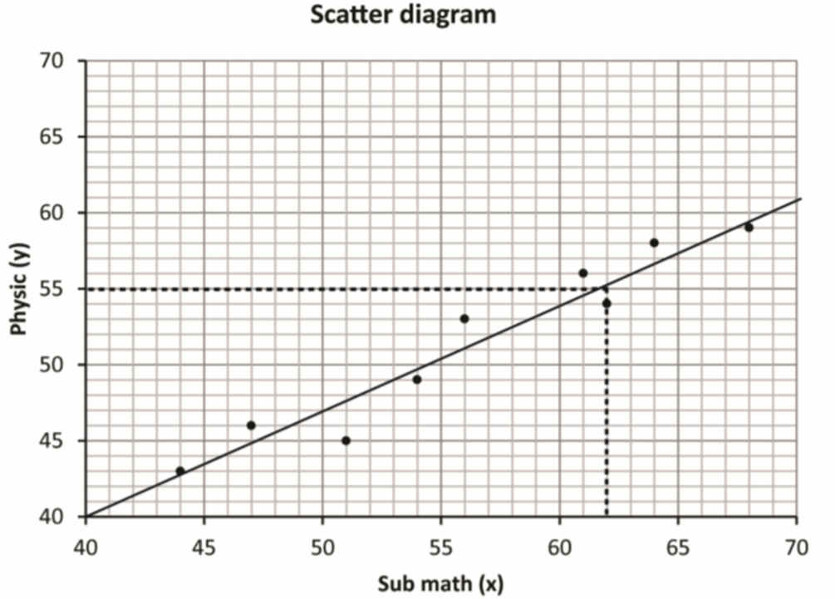
    - On your scatter diagram, draw a line of best fit.
    - Use the line of the best fit to estimate the value of x when y 55. (09 marks)
62

Revision exercise 1
- Given the information in the table below
X | 10 | 15 | 20 | 15 | 30 | 35 | 40 | 45 | 50 | 60
y | 15 | 20 | 35 | 40 | 35 | 50 | 55 | 40 | 54 | 56
  - Represent the above information on a scatter diagram
  - Draw a line of the best fit on your graph
  - Comment on your graph [there is a positive correlation between x and y]
- The table below shows the marks obtained by 10 students in math (M) and physics (P) tests
M | 80 | 75 | 65 | 90 | 95 | 98 | 78 | 65 | 54 | 60
P | 70 | 85 | 70 | 90 | 92 | 88 | 76 | 70 | 73 | 76
  - Represent the above information on a scatter diagram
  - Draw a line of the best fit on your graph
  - Use your graph to estimate the math marks for a student that score 71% in physic. [60]

Spearman’s Rank correlation
Spearman's rank correlation coefficient, denoted by ρ (rho), is a nonparametric measure of rank correlation. It assesses how well the relationship between two variables can be described using a monotonic function
Calculate Spearman's rank correlation, follow these steps:
- Convert the data to ranks: Assign ranks to the values of each variable. If there are ties, assign the average rank.
- Compute the difference (d) in ranks: For each pair of observations, calculate the difference between the ranks.
- Square the differences: Square each difference.
- Sum the squared differences:Add up all the squared differences.
- Apply the formula: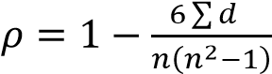 where d is the difference between the ranks of each observation, and (n) is the number of observations

Interpretations of rank correlation coefficient, ρ
Rank correlation coefficient, ρ | Interpretation
0 | No (zero) correlation
0 < ρ ≤ 0.4 | Low positive correlation
0.4 < ρ ≤ 0.7 | Moderate positive correlation
0.7 < ρ ≤ 0.1 | high positive correlation
Note: The reverse is true for respective negative values
Example 1
- The table below shows the marks of eight students in the mid-term test and end of term test in Economics.
Mid-term tests (x) | 99 | 71 | 50 | 67 | 77 | 81 | 96 | 72
End of term test (y) | 99 | 55 | 35 | 60 | 75 | 70 | 99 | 50
Calculate the Spearman’s rank correlation coefficient. Comment on your results.

Solution
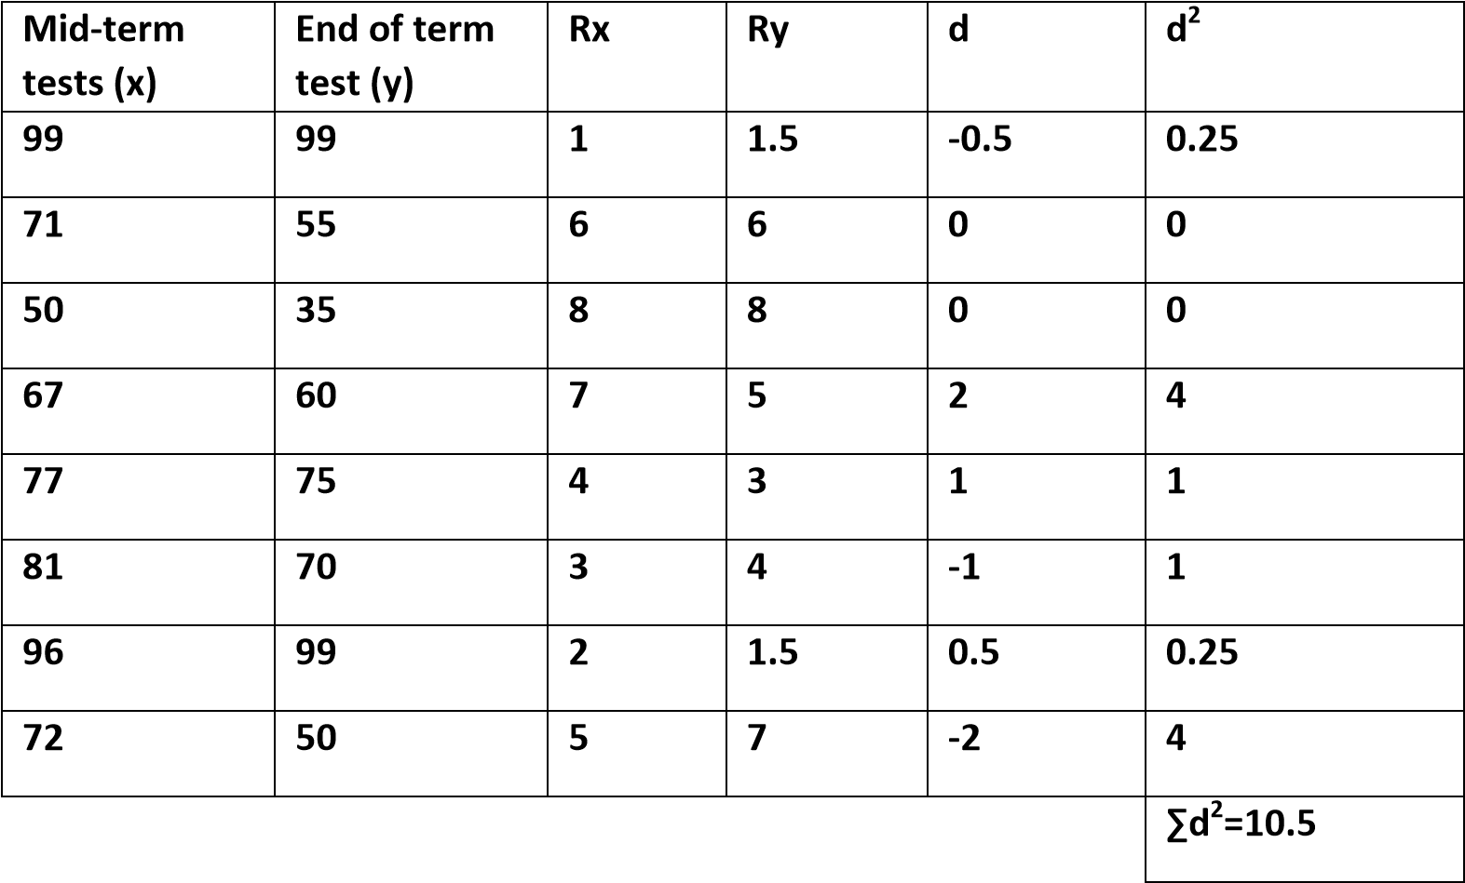
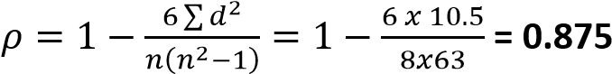

- The table below shows the rank of marks awarded by Judge 1 (Rx) and Judge 2 (Ry) to 7 choir groups A to G.
Choir | A | B | C | D | E | F | G
Rank Judge (Rx) | 2 | 4 | 6 | 1 | 5 | 3 | 7
Rank Judge (Ry) | 2 | 3 | 5 | 1 | 6 | 4 | 7
Calculate Spearman’s rank correlation coefficient between the marks awarded by the two judges. Solution

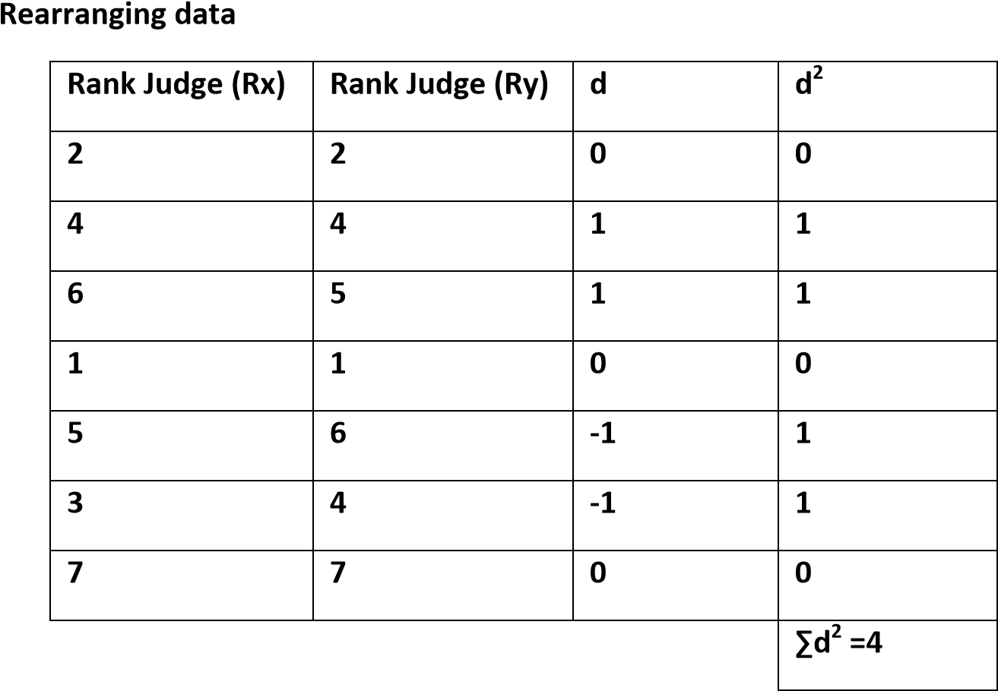
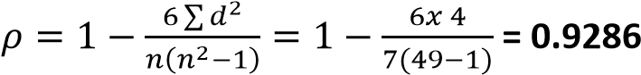
Comment on your results.
There is a high positive correlation between the two Judges’ marks
- The table below shows the oral interview rank (X) and written interview rank (Y) for 12 candidates.
Candidate | A | B | C | D | E | F | G | H | I | J | K | L
Oral interview  Rank (X) | 8 | 10 | 9 | 4 | 12 | 5 | 11 | 7 | 3 | 6 | 1 | 2
Written interview Rank  (Y) | 11 | 12 | 9 | 7 | 10 | 6 | 8 | 5 | 2 | 4 | 1 | 3
Calculate Spearman’s rank correlation coefficient and comment on your results.

Solution
Rearranging data
Candidate | Rx | Ry | d | d²
A | 8 | 11 | -3 | 9
B | 10 | 12 | -2 | 4
C | 9 | 9 | 0 | 0
D | 4 | 7 | 3 | 9
E | 12 | 10 | 2 | 4
F | 5 | 6 | -1 | 1
G | 11 | 8 | 3 | 9
H | 7 | 5 | 2 | 4
I | 3 | 2 | 1 | 1
J | 6 | 4 | 2 | 4
K | 1 | 1 | 0 | 0
L | 2 | 3 | -1 | 1
 |  |  |  | ∑d²= 46
∑
( (
Comment: there is high positive correlation between the oral interview and written interview.
- The table shows scores by 10 students (A to J) in Physics and Mathematics tests
Students | A | B | C | D | E | F | G | H | I | J
Mathematics (x) | 28 | 20 | 40 | 28 | 21 | 31 | 36 | 29 | 33 | 24
Physics (y) | 30 | 20 | 40 | 28 | 22 | 35 | 35 | 27 | 31 | 23
Calculate the rank correlation coefficient for the data and comment on your result.

Solution
Rearranging data
Student | Rx | Ry | d | d²
A | 6.5 | 5 | 2.5 | 2.25
B | 10 | 10 | 0 | 0
C | 1 | 1 | 0 | 0
D | 6.5 | 6 | 0.5 | 0.25
E | 9 | 9 | 0 | 0
F | 4 | 2.5 | 1.5 | 2.25
G | 2 | 2.5 | -0.5 | 0.25
H | 5 | 7 | -2 | 4
I | 3 | 4 | -1 | 1
J | 8 | 8 | 0 | 0
SUM |  |  |  | 10
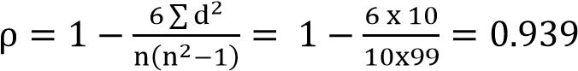

Comment: there is a high positive correlation between the marks of physics and mathematics

- The table below shows the heights to nearest cm and the masses to the nearest kg of 10 students, A to J.
Student | A | B | C | D | E | F | G | H | I | J
Mass (kg) (x) | 53 | 68 | 57 | 52 | 66 | 64 | 63 | 58 | 57 | 68
Height (cm)(y) | 148 | 172 | 156 | 139 | 163 | 158 | 168 | 151 | 144 | 170
Calculate the rank correlation coefficient for the data.

Rearranging data
Student | Rx | Ry | d | d²
A | 10 | 8 | 2 | 4
B | 1.5 | 1 | 0.5 | 0.25
C | 7.5 | 6 | 1.5 | 1.25
D | 9 | 10 | 0.5 | 0.25
E | 3 | 4 | -1 | 1
F | 4 | 5 | -1 | 1
G | 5 | 3 | 2 | 4
H | 6 | 7 | -1 | 1
I | 7.5 | 9 | -1.5 | 2.25
J | 1.5 | 2 | -0.5 | 0.25
sum |  |  |  | 17
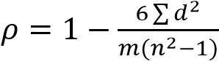
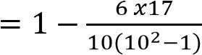
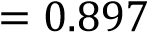
Comment on your answer (07marks)
There is high positive correlation between height and weight of student.

Revision exercise 2
- The table below shows marks obtained in sub-Math and Physics by nine students.
Sub-Math (x) | 51 | 62 | 64 | 47 | 54 | 44 | 68 | 61 | 56
Physics (y) | 45 | 54 | 58 | 56 | 49 | 43 | 59 | 56 | 53
Calculate the spearman’s rank correlation coefficient and comment on the result. [ρ = 0.967]
- The table below shows the marks obtained by 8 students in English and history tests
Eng. (E) | 60 | 80 | 75 | 85 | 68 | 90 | 95 | 78
Hist. (H) | 70 | 75 | 80 | 78 | 85 | 90 | 96 | 83
Calculate the spearman’s rank correlation coefficient and comment on the result. [ρ = 0.57]

- The table below shows the marks obtained by 10 students in Math (M) and Physics (P) tests
M | 15 | 20 | 54 | 36 | 40 | 35 | 16 | 36 | 18 | 40
P | 21 | 16 | 40 | 35 | 16 | 20 | 13 | 20 | 30 | 25
Calculate the spearman’s rank correlation coefficient and comment on the result. [ρ = 0.38]

TOPIC 2/3: Vectors
Vectors
A vector is a quantity which has both magnitude and direction. Examples include, force, displacement, acceleration, momentum and velocity.
Representation of a vector
A vector is represented by a line with an arrow to indicate the direction of the vector.

O

A

OA

where the order of the letters shows the direction
Vectors in dimensions
Vectors can be represented in three dimensions as I, j and k along the x, y and z- axes respectively
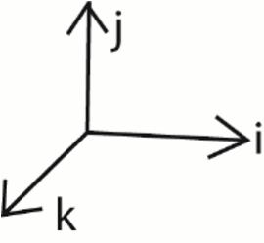
Resultant of vectors
When several vectors (V₁, V₂, V₃… V_{n}) are acting on a point object, the net vector R, is calculated as the vector sum
R = V₁ + V₂ + V₃ + … + Vn = 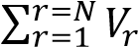
Example 1
Find the resultant of the following vectors
- (2i + 3j + 3k) and (2i + 4j – 8k)
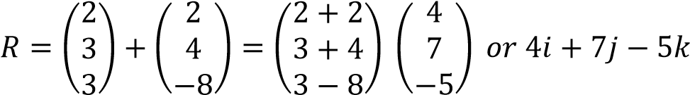
- (7i – 4j + 3k), (5i -2j + 8k), (i –k)
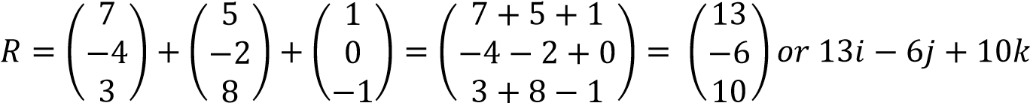

Example 2
The resultant of (5i -2j), (7i + 4j), (ai + bj) and (-3i + 2j) is (5i + 5j). Find the values of a and b.
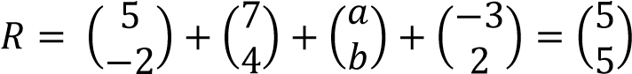
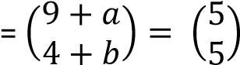
9 + a = 5; a = -4 also 4 + b = 5; b = 1
Example 3
The resultant of the forces (3i + (a-c)j)N, ((2a + 3c)I + 5j)N and (4i, 6j)N acting on a particle is (10i
+ 12j)N. find
- Values of a and c

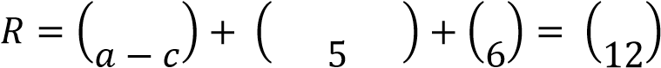
(
i) + 3(ii
)

5
a = 6; a
= 1.2

from

eqn. (ii)

c = 0.2

2a + 3c + 7 = 10 2a + 3c = 3 ……….. (i) a –c +11 = 12
a – c = 1 ………….. (ii)

- magnitude of (2a + 3c)I + 5j

R = (2a + 3c)I + 5j = (1.2 x 2 + 3 x 0.2)i + 5j = 3i + 5j
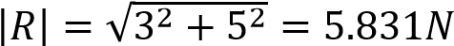

Magnitude or modulus of a vector
This is the length of a vector
- Given R = xi + yj; 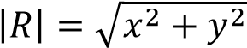
- Given R = xi + yj + zk; 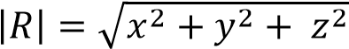
Example 5
Find the magnitude of the following vectors
and tests on digitaltechers.co.ug
- 3i + 4j; 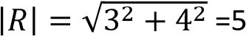
- 3i + 2j – 6k; 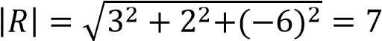

Direction of a vector
Consider R = xi + yj
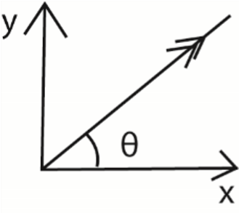
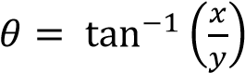
Example 6
Find the magnitude and direction of the resultant of each of the following
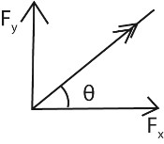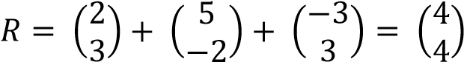
)
a
(

i + 3j)N, (5t
(2
–

j)N,
(
2
-
i, 3j
3
)

N
6569

)
(
b

=
2N

𝜃

;

(
4
4
)

45
=
0

𝜃

;

(
0
;

)
= 180
0

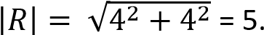
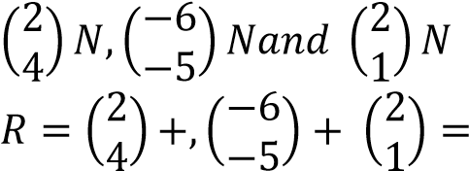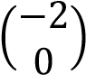
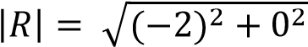

Example 7
Four forces of ai + (a-1)j, 3i + 2aj, 5i -6j, and –i -2j act on a particle. The resultant forces make an angle of 45⁰ with horizontal. Find a. Hence determine the magnitude of the resultant force.
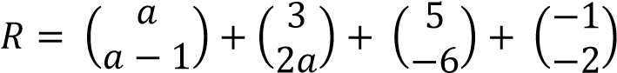
𝑎
:
7
3
𝑎
;
9

;

0

=
1

a + 7 = 3a
–

9
, a =
8

𝑅

(
𝑎

𝑎

)

(

𝑥

)

(

)

|
𝑅
|

√

=
21.21N

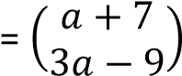

Unit vector
This a vector whose magnitude is unit (1)
Unit vector of r denoted by r = 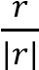
Example 8
Find the unit vector of a = 6i -2j + 3k Solution
a = 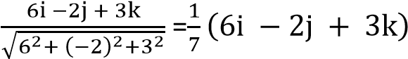
Parallel vectors
If vectors a and b are parallel, then one of them is a scalar multiple of the other.
If a vector r of magnitude | | moves in direction xi + yj + zk then, r =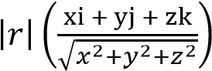
Example 9
Find the vector, V which has a magnitude of 15 units and is parallel to 16i + 12j
V = 15 x 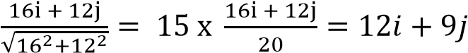
Example 10
A body of velocity v and of magnitude 20m/s moves in the direction 6i + 8j. Find V.
V = 20 x 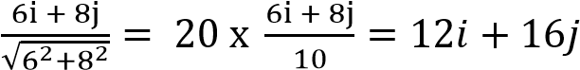
Example 11
A force of magnitude 12N acts on a body in the direction 2i + j + 2k. Find the force
V = 12 x
Example 12

The force A of magnitude 5N in the direction with unit vector 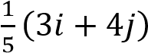 and force B of magnitude 13N in the direction with unit vector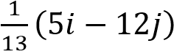. Find the resultant forces of A and B.
F =
(

)

+
(

)

(

)

|
𝐹
|

√

=
11.3137N

FA = 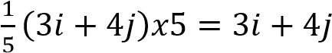
FB =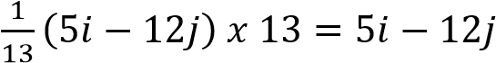

Example 13
A particle P moves through a displacement of 2m when acted o by two forces F₁ and F₂. Find the work done by the resultant force, if F₁ = i – j and F₂ = 10 N and acts in the direction 4i + 3j
Solution 
and tests
on
digitaltechers.co.ug
F =
(

)

(

)

=

(

)

|
𝐹
|

√

=
10.2956N

W =
|
𝐹
|

𝑥

𝑑

x 2 = 20.5912J
10.2956

F₁ = i – j
F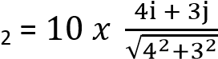= 8i + 6j

Revision exercise 1
(Answers are given in square brackets at the end of each question)
- Find the resultant of each of the following forces (a) (6i + 2j)N, (-5i + j)N, (3i – 3j)N. [(4i)N]
  - (2i + 4j)N, (3i -5j), (6i +2j)N, (-7i – 7j)N. [(4i -6j)N]
  - (2i + 3j -7k)N, (2i + 5k)N, (3j + 4k)N. [(4i + 6j + 2k)N]
- The resultant of forces (5i + 7j), (ai + bj) and (bi –aj)N is a force (11i + 5j)N. Find a and b. [a = 4, b = 2]
- Find the magnitude and direction of the resultant of each of the following;
  - (-2i + 5j)N, (I + 2j)N. [ 7.07N at 98.1⁰]
  - (6i + 2j)N, (4i – 3j)N. [10.05N at 354.3⁰]
  - (3i + 2j), (-5i + j)N. [3.61N at 124⁰]
- A force of magnitude 50N acts on a body in the direction 24i + 7j. Find the force. [(48i + 14j)]
- Two forces F₁ and F₂ have magnitude αN and βN and act in the direction i -2j and 4i + 3j respectively. Given that the resultant of F₁ and F₂ is (48i + 14j). Find the magnitude of αN and

βN. *α = 8√ N and β = 50N+
- If a = 3i + 4j, b = 4i + 20j and c = 5i – 19j; find the
  - resultant of a and b [(7i + 24j)]
  - resultant of a and c [(8i – 15j)]
  - vector is parallel to a and has magnitude of 15 unit [(9i + 12j)]
  - vector parallel to (a + b) and has a magnitude of 100 units [(28i + 96j]
- If a = 2i + 5j, b = -7i + 7j and 14i. Find the;
  - resultant of a and b [(-5i + 12j)]
  - resultant of a, b and c [(9i + 12j)]
  - |b| [7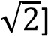
  - |a + b + c| [15units]
  - vector is parallel to a and has a magnitude of 5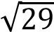 units. (10i + 25j)
  - Vector is parallel to (a + b + c) and has magnitude 90 units. [(54i + 72j)]
- If a = i -3j + 2k, b = 5i + 4j and c = 3i + j + 4k. Find the
  - resultant of a and b [(6i + j + 2k)]
  - resultant of a, b and c.[(9i + 2j + 6k)
  - |a| [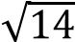]
  - |a + b + c|[11units]
  - Vector parallel to (a + b + c) and has magnitude 5 units 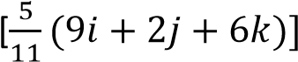
- If a = 2i + 7j + 7k, b = 6i -3j + 2k and c = -4j -3k. find the
  - resultant a and b [8i +4jj + 9k]
  - resultant a and c [2i + 3j + 4k

  - |b| [7units]
  - |a + b + c| [10 units]
  - vector is parallel to |a + b + c| and has magnitude of 50 units [40i + 30k]

Scalar products or dot products
The dot product of two vectors p=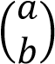 and q= 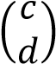 is given by p.q 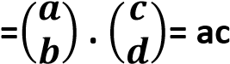- bd
The dot product of two vectors a and b inclined at angle θ is given by
a.b = 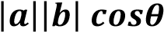
Note
If two vectors are perpendicular then the angle between them is 90⁰ and
a.b = 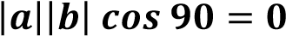
Example 14

The vector a = 3i + 2j and b = 4i – 5j
Determine
- Magnitude of b
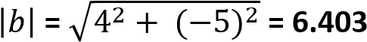

- A.b (05marks)

(3 x 4)+ (2 x -5) = 12 – 10 = 2
Example 15
Given a = 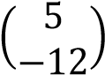 and b 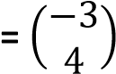, find the;
- dot product of a and b. (02 marks)
(5 x -3) + (-12x 4) = -93
- angle between the vectors a and b. (03 marks)
Solution
Let the angle be θ
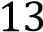x 5 cosθ = 93
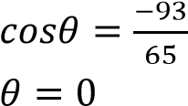
Example 16
Point A, Band C have position vectors, 2j, 4i, and 2i – 2j respectively in the x – y plane.
- Find 2OA + 3OB – 4OC. (04 marks)
- Determine;
  - AB and AC (04marks)
AB = AO + OB =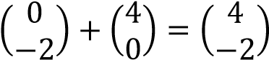
AC = AO + OC = 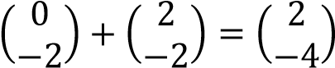
  - AB + AC (03mark)
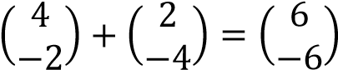
  - angle BAC (05 marks)
Dot product of vector BA = 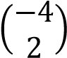and AC = 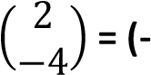4 x 2) + (2 x -4) = -16
Let the angle be θ
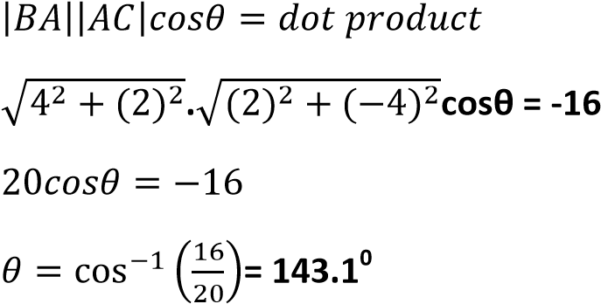

Example 17
If OA = 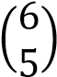, OB = 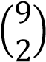 and OC =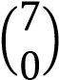
- find the vectors;
  - BC
Solution
BC = BO + OC
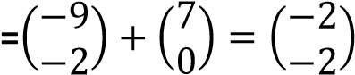
  - AB (06 marks)
AB = AO + OB
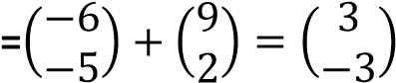
- Show that vectors AB and BC are perpendicular. (03 marks)
For perpendicular vectors AB.BC =0
AB.BC = 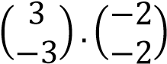= (3 x -2)+(-3 x -2) = -6 + 6 = 0
Hence AB and BC are perpendicular
- Determine the magnitude of the vector 2BC – 3AB. (06 marks)
2BC – 3AB = 2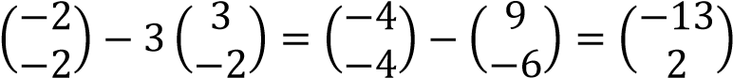

Example 18
If a = i – 2k and b = 3i – 3j + k, find
(i) a.b (ii) the angle between a and b
Solution
- a.b = 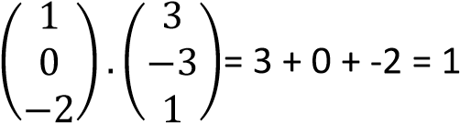
- 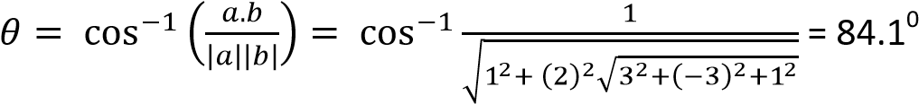
Example 19
If p = 2i – j + 3k and q = i + 4j + 3k; find the angle between p and q.
Solution
p.q = 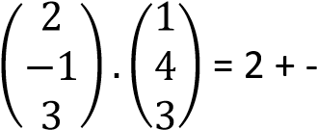4 + 9 = 7
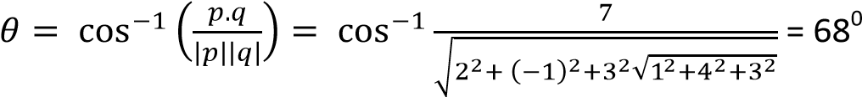
Example 20
If the angle between two vectors a = xi + 2j and b = 3i + j is 45⁰.Find the two possible values of constant x.
Solution
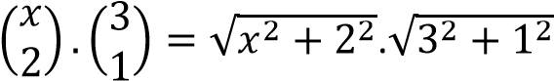

x
2

+
3x
–

4
=
0

(
x + 4)(x
-
1)
=
0

x =
-
4
and x =
1

3x + 2 = 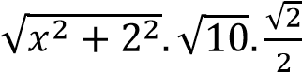
(3x + 2)² = (x² + 4). 10 x
Example 21
If p = 2αi + 7j – k and q = 3αi + αj + 3k.Find the value of the scalar α if the vectors are perpendicular Solution
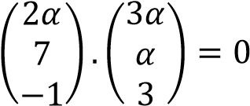
6α² + 7α – 3 = 0
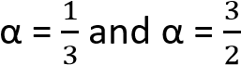
Example 22
The points P and Q have position vectors OP= –2i – 5j and OQ = i – 2j respectively. R is appoint such that OR = OP + λPQ.
- Find the:
  - value of OP.OQ
-1 x 2 + -5 x -2 = 8
  - angle between the two vectors OP and OQ. (07 marks)
OP.OQ=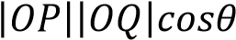
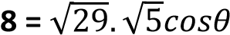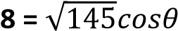
cosθ = 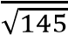
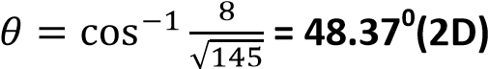

- Determine the
  - vector PQ
PQ = PO + OQ
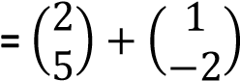

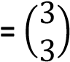 Or (3i + 3j)
  - vector OR in terms of λ
OR = 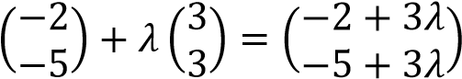
  - the value of λ for which OR is perpendicular to PQ. (08 marks)
When OR is perpendicular to PQ
Then OR.PQ = 0
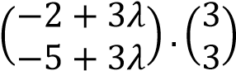
-6 + 9λ- 15 + 9λ =
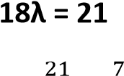
λ = 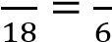

Revision exercise 2
(Answers are given in square brackets [ ] at the end of each question)
- Find the scalar products for each of the following pairs of vectors.
  - a = 2i + j, b = i - 3j [-1] (ii) a = 3i, b = -2i + j [-6]


(iii) a = 5i + j - 2k, b= 4i + 3j – 8k [39] (iv) 2i + 4j – 15k and -8i + 2j – k [7]

viii)
(
(

)

(

)

[73
0
]

vii)
(
(

)

𝑎𝑛𝑑

(

)

[8]

(
vi)
(

)

𝑎𝑛𝑑

(

)

[2]

(
v)
(

)

𝑎𝑛𝑑

(

)

[82
0
]

(
vi)
(

)

𝑎𝑛𝑑

(

)

[92
0
]

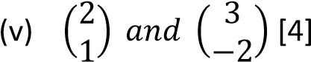
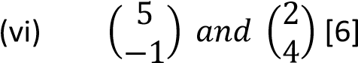
- Find the angles between each of the following pairs of vectors
  - 3i + 4j and 5i – 12j [121⁰]
  - 3i and -2j [90⁰]
  - 2i + 3j – 6k and 2i + j + 2k [10⁰]
  - i + 2j – k and –I + 2j – k [48⁰]
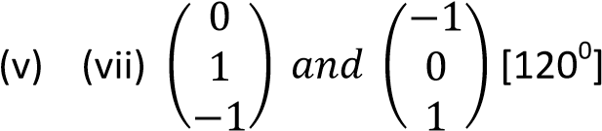
- If a = αi + 2j – k and b = 5i –αj + k. Find the value of the scalar α if the vectors are perpendicular [
- If a = 2i + αj and b = -α – k. Find the value of the scalar α if the vectors are perpendicular [0]
- If a = 4i + 5j and b = qi – 8j. Find the value of scalar q if the vectors are perpendicular. [10]
- If a = 6i – j and b = 2i + pk. Find the value of scalar p if the vectors are perpendicular [12]
Given 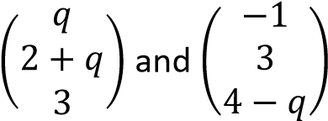 are perpendicular vectors. Find the value of q. [18]
- If a = qi + 8j +(3q + 1)k and b = (q+1)I + (q-1)j – 2k. Find the value of the possible values of constant q if the vectors are perpendicular. [2 or -2]
TOPIC 3/3: Trigonometry
Competency: The learner analyses trigonometric concepts to solve real-world problems in

various fields.
Trigonometry
The word ‘trigonometry’ suggests ‘tri’-three, ‘gono’-angle, ‘metry’-measurement. As such, trigonometry is basically about triangles, most especially right-angled triangles.

Important to note
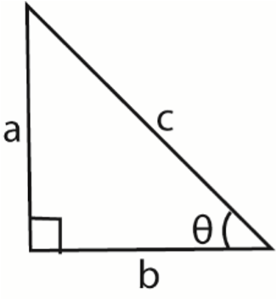
(
a
)

For a right angled

triangle below

• sinθ =

• cosθ =

• tanθ =

(
b
)

All
positive angles are measured
cosecθ =
1
𝑠𝑖𝑛
θ
=
𝑐
𝑎

secθ =
1
𝑐𝑜𝑠
θ
=
𝑐
𝑏

cotθ =
𝑐𝑜𝑠
θ
𝑠𝑖𝑛
θ
=
𝑏
𝑎

anticlockwise from positive x-axis
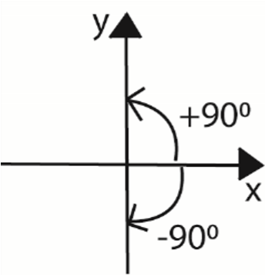
(c) A circle drawn with the centre O, divides the co-ordinate axis into four equal parts called quadrants
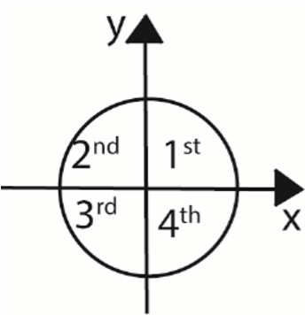
The quadrants are also labelled anti-clockwise from the positive x – axis.
The signs the trigonometric ratios in the quadrants are given below
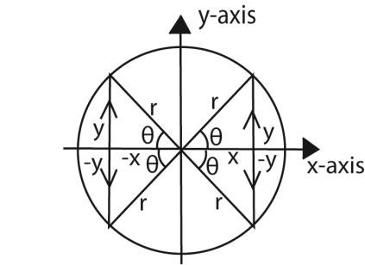
Ratio | Quadrant
Ratio | 1st | 2nd | 3rd | 4th
cosθ | + | - | - | +
sinθ | + | + | - | -
tanθ | + | - | + | -
secθ | + | - | - | +
cosecθ | + | + | - | -
cotθ | + | - | + | -
Note
- If θ is the angle in the 1st quadrat
- In the 2nd quadrat the angle is (180 – θ)
- In the 3rd quadrat the angle is (180 + θ)
- In the 4th quadrat the angle is (360 –θ)
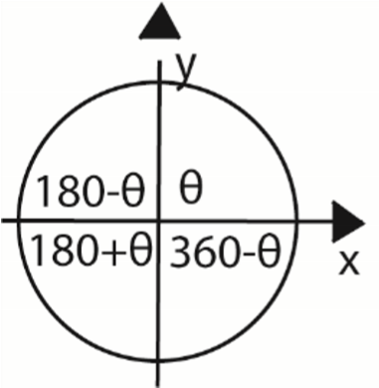
Solving equations
We make use of the quadrants to find the ranges of values within which the angle follows

Example 1
Solve the following equations for 0⁰ ≤ θ ≤360⁰
- 3cosθ + 2 = 0 Solution
cosθ = 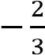
But cos is negative in the 2nd and 3rd quadrants.
Ignoring the negative sign, the angle obtained is referred to as the key or principle angle, i.e. key
angle = 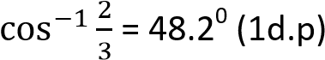
In the 2nd quadrant, θ = 180 – 48.2 = 131.8⁰
In the 3rd quadrant, θ = 180 + 48.2 = 228.2⁰
{θ: θ= 131.8⁰, 228.2⁰}
Note that: the key angle s not part of the solution but only a guide.
- 4cos²θ – 1 = 0 Solution
cosθ = 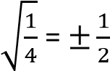
Key angle, θ = 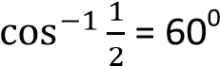
When cosθ = ½ (positive is 1st and 4th quadrants)
1st quadrant θ = 60⁰
4th quadrant θ = 360 – 60 = 300⁰
When cosθ = -½ (positive is 2nd and 3rd quadrants)
3rd quadrant θ = 180 – 60 = 120⁰ 4th quadrant θ = 180 + 60 = 240⁰
{θ: θ= 60⁰, 120⁰, 240⁰, 300⁰}

- cosecθ + 2 = 0 Solution cosecθ = -2 => sinθ = - ½ (taking reciprocal)
Key angle = 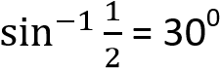
In the 3rd quadrant θ = 180 + 30 = 210⁰
In the 4th quadrant θ = 360 – 30 = 330⁰
{θ: θ= 210⁰, 330⁰ }

- 3sec²θ – 4 = 0 Solution
secθ = 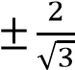=> cosθ =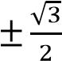
Key angle = 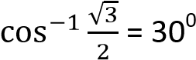
For cosθ = 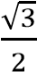; θ = 30⁰, 330⁰
For cosθ = 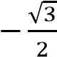; θ = 120⁰, 210⁰
{θ: θ= 30⁰, 120⁰, 210⁰, 330⁰}

(d) Definitions of angle
- Acute angle is an angle between 0⁰ and 90⁰.
It lies in the 1st quadrant
- Right angle is an angle = 90⁰
- Obtuse angle is an angle between 90⁰ and 180⁰. It lies in the 2nd quadrant
- Reflex angle is an angle between 180⁰ and
360⁰. It lies in the 3rd and 4th quadrant Example 2
- If sinθ = and 0⁰ ≤ θ ≤ 360⁰. Find the possible values of 3tanθ – cotθ
Solution
If sinθ = ; θ lies in 1st or 2nd quadrants
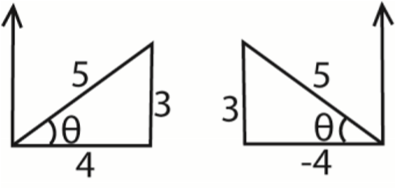
In 1st quadrant
3tanθ – cotθ = 3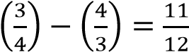
In 2nd quadrant
3tanθ – cotθ = 3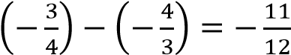
the possible values are 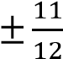
- If cosθ = 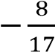 and θ is reflex, find the value of 4sec²θ + tanθ
Solution
If cosθ = 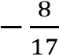 and θ is reflex, θ lies in the 3rd quadrant
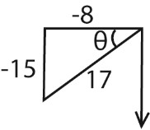
4sec²θ + tanθ = 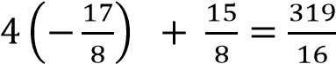

Example 3
Solve for θ, where θ⁰ ≤ θ ≤ 360⁰
(i) 3tan²3θ = 1 Solution
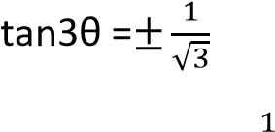
taking tan3θ =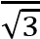
- 3θ = 30⁰, 210⁰,390⁰,570⁰,750⁰, 930⁰ θ = 10⁰, 70⁰, 130⁰, 190⁰, 250⁰, 310⁰
taking 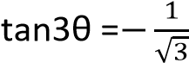
- 3θ = 150⁰, 330⁰,510⁰,690⁰,870⁰, 1050⁰ θ = 50⁰, 110⁰, 170⁰, 230⁰, 290⁰, 350⁰
{θ: θ=10⁰, 50⁰, 70⁰, 110⁰, 130⁰, 170⁰, 190⁰,
230⁰, 250⁰, 290⁰, 310⁰, 350⁰} Note
- If θ⁰ ≤ θ ≤ 360⁰ then θ⁰ ≤ 3θ ≤ 1080⁰
[multiply the interval through by 3]

(ii) 2cos2θ + √ = 0
Solution 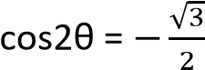 and θ⁰ ≤ 2θ ≤ 720⁰
2θ = 150⁰, 210⁰, 510⁰, 570⁰
{θ: θ = 75⁰, 105⁰, 255⁰, 285⁰}
Set square angles: 30⁰, 45⁰, and 60⁰
- From equilateral triangle ABC with side
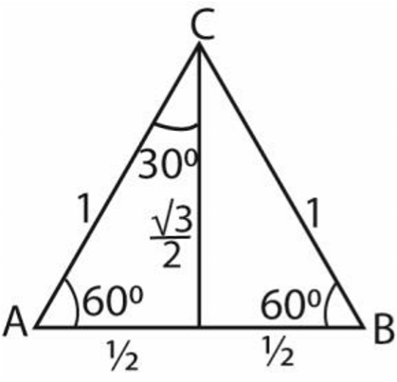
equal to 1 unit

cos 60
0

=
sin
30
0

=
1

cos 30
0

=
sin
60
0

=

√

tan 30
0

=
cot
60
0

=

1
√

tan 60
0

=
30
cot
0

=

√

- From the right angled triangle PQR below
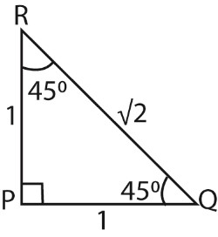
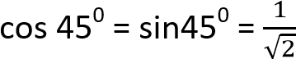
tan45⁰ = 1

Example 4
Triangle OAB is such that Angle AOB =90⁰, angle ABO = θ, 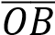 = 14.4cm and 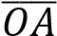 = 6cm.
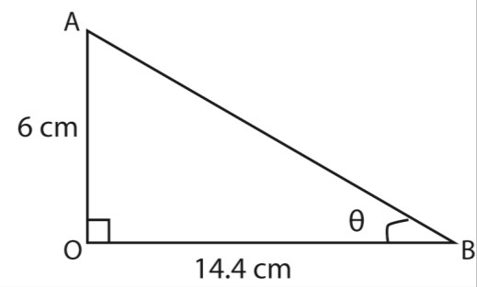
Find sinθ + cotθ
Solution
tan θ = 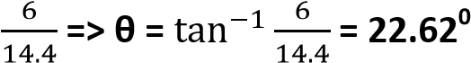
sinθ + cotθ = sin 22.62 + cot 22.62
= 0.3846 + 2.4000
= 3.7846

Example 5
Without using tables or calculators find the value of
- cos240⁰
Solution
- tan 3990⁰ Solution
tan 3990⁰ = tan [(360 x 11)+ 30]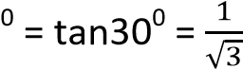
- sin 570⁰ Solution
sin 570⁰ = sin {(360 x 1) + 210]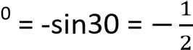
- sec 225⁰
Solution

The Pythagoras theorem
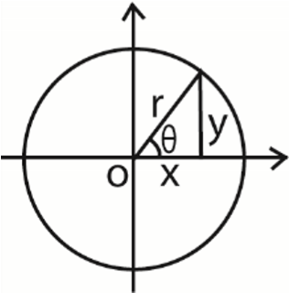
For any acute angle θ x = rcosθ and y = rsinθ By Pythagoras theorem
x² + y² = r²
Substituting for x and y (rcosθ)² + (rsinθ)² = r² r²(cos²θ + sin²θ) = r² cos²θ + sin²θ = 1
Now tanθ = 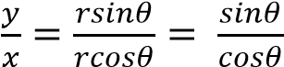
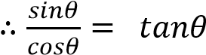
Identities cos²θ + sin²θ = 1 …………………(i) Identity (i) cos²θ
1 + tan²θ= sec²θ ……………… (ii) Identiy (i) sin²θ
1 + cot²θ = cosec²θ ………….(iii)

Example 6
Show that
(a) sec²θ + cosec²θ = sec²θcosec²θ Solution
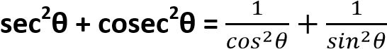
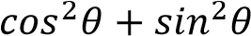
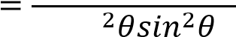
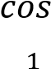
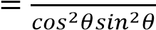
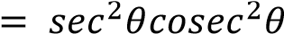
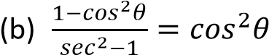
Solution
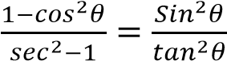
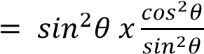
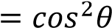 as required

(i) sin²θ + (1 + cosθ)² = 2(1 + cosθ) Solution sin²θ + (1 + cosθ)²
= sin² θ + 1 + 2cosθ + cos² θ
= sin² θ + cos² θ + 1 + 2cosθ
= 1 + 1 + 2cosθ (Recall that sin² θ + cos² θ = 1) = 2 + 2cosθ = 2(1 + cosθ) sin² θ + (1 + cosθ)² = 2(1 + cosθ)
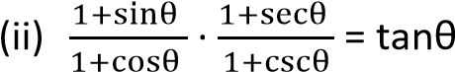
Solution
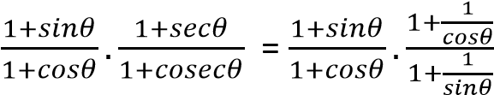
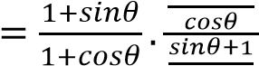
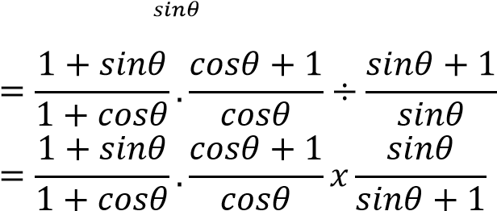
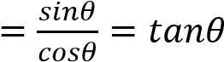
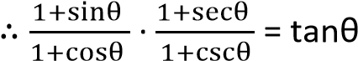
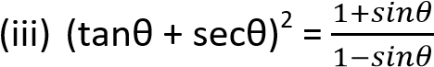
Solution
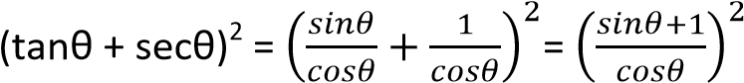
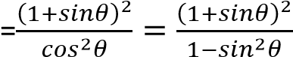
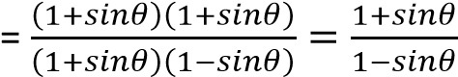
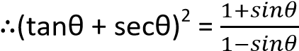

Example 7
Solve the following equations for 180⁰ ≤ x ≤ 360⁰
- sec²θ – tanθ = 1 Solution sec²θ – tanθ = 1
  - + tan²θ – tanθ = 1
  - (d)
tan θ – tanθ = 0

tanθ(tanθ-1) = 0
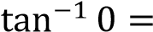 0
Either tanθ = 0; θ = 0

Or tanθ = 1, θ = 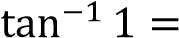45⁰, 225⁰

Hence θ = (0⁰, 45⁰, 225⁰)
Note that in the 1st and 3rd quadrants tanθ is is positive.
- 3sin²θ + cosθ + 1 = 0
Solution
3(1- cos²θ) + cosθ+ 1 = 0
  - cos²θ – cosθ – 4 = 0
(e) (cosθ + 1)(3cos θ -4) = 0
2sinx – 1 = 0 sinx = ; x = 30⁰, 150⁰ x = (30⁰, 150⁰, 270⁰)
Note that in the 1st and 2nd quadrants sinθ is positive while in the 3rd and 4th quadrants sinθ is negative
2cos²θ + sinθ – 1 = 0
Solution
2(1 – sin²θ) + sinθ – 1 = 0
2sin2θ – sinθ – 1 = 0
(sinθ – 1)(2sinθ + 1) = 0
Either sinθ = 1 or sinθ = 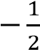
When sinθ = 1; θ = 90⁰
When sinθ = 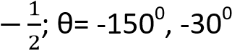, 210⁰, 330⁰
*θ: θ= -150⁰, - 30⁰, 90⁰ for given range]
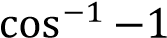
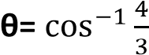
= 1800 Solution
Either θ=

1st approach
Or = no value
√3sinθ = 1- cosθ
Hence = 180⁰
Squaring both sides
(c) 2cos²x = sinx + 1
3sin²θ = 1 – 2cosθ + cos²θ
Solution 2 2
3(1 – cos θ) = 1 – 2cosθ + cos θ
2(1- sin² x) = sinx + 1
4cos²θ – 2cosθ – 1 = 0 2
2sin x – sinx – 1 = 0
(2cosθ + 1)(cosθ – 1) = 0
(sinx +1)(2sinx -1) = 0
Cosθ = 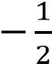 cosθ = 1
Either sinx + 1 = 0
00
Sinx = -1; x = 2700 θ = ± 120 θ = 0
*θ: θ= 0⁰, ± 120⁰]
Or
2nd approach
cosθ + √3sinθ = 1
√3sinθ = 1- cosθ
Dividing through by cosθ
√3tanθ = secθ – 1
Squaring both sides
3tan²θ = sec²θ – 2secθ + 1
3tan²θ = sec²θ – 2secθ + 1
3[sec²θ – 1] = sec²θ – 2secθ + 1 2sec²θ + 2secθ – 4 = 0 sec²θ + secθ – 2 = 0 (secθ + 2)(secθ – 1) = 0 secθ = -2 or secθ = 1 cosθ = - or cosθ = 1
*θ: θ= 0⁰, ± 120⁰]
3rd approach
√3sinθ = 1- cosθ
Dividing through by sinθ
√3 = cosecθ – cotθ
Rearranging
√3 + cotθ = cosecθ
Squaring both sides
3 + 2√3cotθ + cot²θ = cosec²θ 3 + 2√3cotθ + cot²θ = 1+ cot²θ cotθ = -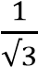; => tanθ = -√3
*θ: θ= -60⁰, 120⁰]

Example 8
- Given that tanθ = ½ Evaluate cosec²θ –sec²θ without using mathematical tables or calculator.
Solution
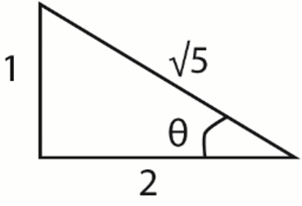
θ = 5
secθ = 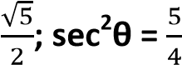
⇨ cosec²θ –sec²θ = 5 -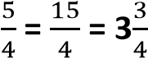

- Prove that 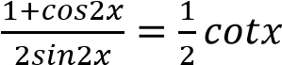
Solution
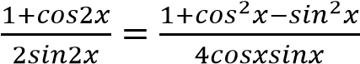
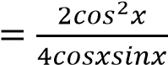
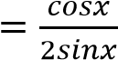
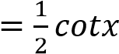 as required
Hence solve the equation 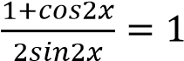 for
0⁰ ≤ x ≤ 180⁰.
Solution
Hence 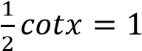
Cot x = 2 x = 26.6⁰
- Show that 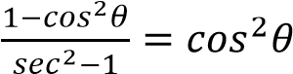
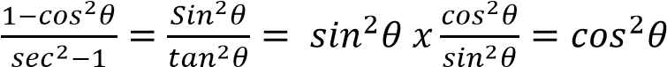 as required
Hence, solve the equation 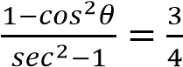 for
0⁰ ≤ θ ≤ 90⁰.
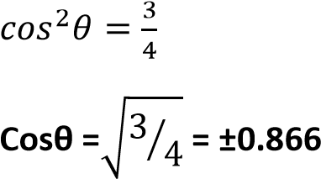

For cosθ = 0.866; cos⁻¹(0.866) = 30⁰, 330⁰
For cosθ = -0.866; cos⁻¹(-0.866) = 150⁰, 210⁰
Hence θ = 30⁰ for 0⁰ ≤ θ ≤ 90⁰

Example 9
(a) Given that 7 tanθ + cotθ = 5secθ, derive a quadratic equation for sinθ. Hence or otherwise, find all values of θ in the interval 0⁰ ≤ θ ≤ 180⁰ which satisfy the equation, giving your answer to the nearest 0.10 where necessary
Solution
7 tanθ + cotθ = 5secθ
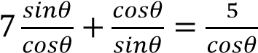
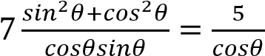
7sin² + cos² = 5sin
7sin²θ + (1 – sin²θ) = 5sinθ
6sin² – 5sin + 1 =0
(3sin – 1)(2sin -1) = 0
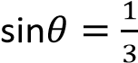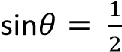
θ = 19.5⁰, 160.5⁰ θ = 30⁰, 150⁰
*θ: θ= 19.5⁰, 30⁰, 150⁰, 160.5⁰]
Example 10
Find the solution of 3cotθ + cosecθ = 2 for 0⁰ ≤ θ ≤ 180⁰.
Solution
3cotθ + cosecθ = 2
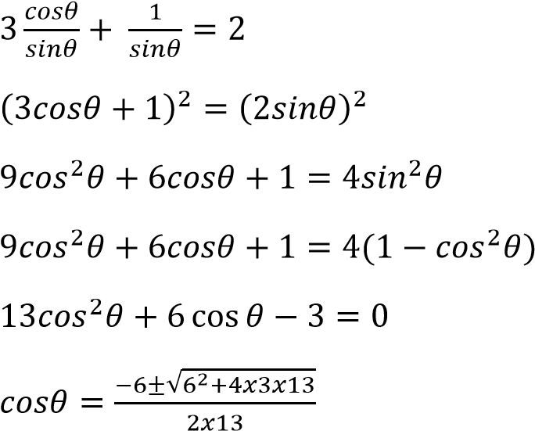
cosθ = 0.3021 cosθ = 0.7637 θ = 72.40 θ = 40.2
*θ: θ = 72.4⁰, 40.2⁰ ]
Elimination of trigonometric parameter
This involves the use of identities to eliminate the trigonometric values in equation
Example 11
- If x = tanθ + secθ and y = tanθ – secθ; show that xy + 1 = 0 Solution x + y = tanθ x – y = 2secθ
secθ = 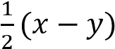
Using identity: 1 + tan²θ = sec²θ
1 + (x + y) 2 = 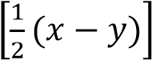
4 + x² + 2xy + y² = x²-2xy + y² 4xy + 4 = 0 xy + 1 = 0 as required
- x = 2 + 3sinθ and y = 3 + 2cosθ show that
4(x – 2)² + (y – 3)² = 36 Solution x = 2 + 3sinθ => sinθ = 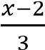 y = 3 + 2cosθ => cosθ = 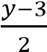 Using identity sin²θ + cos²θ= 1
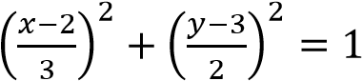
4(x – 2)² + (y – 3)² = 36 as reqyured (c) x = 2sinθ and y = tanθ, prove that
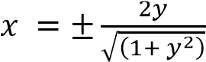
Solution x = 2sinθ; => cosecθ = y = tanθ; => cotθ = Using identity: 1 + cot²θ = cosec²θ
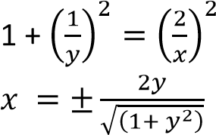

Revision exercise 1
1. Solve for θ, where θ⁰ ≤ θ ≤ 360⁰
- secθcosecθ + 2secθ – 2cosecθ – 4 = 0 [θ:
θ = 60⁰, 210⁰, 300⁰, 330⁰]

- tan²θ – (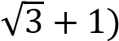tanθ + √ = 0
[θ: θ = 45⁰, 60⁰, 225⁰, 240⁰]
- Show that
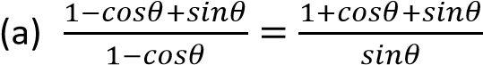
  - tanθ + cotθ = secθcosecθ
  - cos⁴θ-sin⁴θ+1 = 2cos²θ
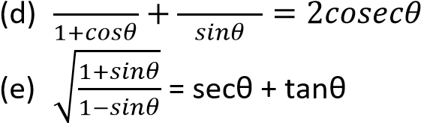
- Solve the following equations for
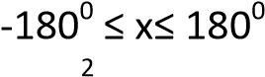
(i) 2cos θ + sinθ – 1 = 0 *θ:
θ = -150⁰, - 30⁰, 90⁰] (ii) sin2θ + 5cos2θ = 3
*θ: θ = ±45⁰, ±135⁰]
(iii) 4cot²θ + 24cosecθ + 39 = 0
*θ: θ = 16.6⁰, 23.6⁰, 156.4⁰, 163.4⁰]

4. Solve each of the following equations in the stated range
- 4cos²θ + 2sin θ = 4 0⁰ ≤ θ ≤ 360⁰
*θ: θ = 0⁰, 48.6⁰, 131.4⁰, 180⁰, 360⁰]
- 2sec²θ – 4tanθ – 2 = -180⁰ ≤ θ ≤ 360⁰
*θ: θ = -135⁰, -161.6⁰, 18.4⁰, 45⁰]
- 5cos²3θ = 3(1 + sin3θ), 0⁰ ≤ θ ≤ 360⁰
*θ: θ = 7.9⁰, 52.1⁰, 90⁰, 127.9⁰, 172.1⁰]
- Solve for θ; 00 ≤ θ ≤ 3600 (a) tanθ + 3cotθ = 4
*θ: θ = 45⁰, 71.6⁰, 225⁰,251.6⁰]
(b) 4cosθ – 3sinθ = 2
*θ: θ = 29.50, 256.70]
- Solve
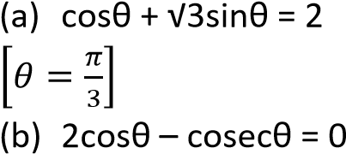 0 ≤ θ ≤ π
0⁰≤ θ≤ 270⁰
*θ: θ = 45⁰, 225⁰]
(c) 2sin²θ + 3cosθ = 0 | 0⁰≤ θ≤ 360⁰
*θ: θ = 240⁰, 120⁰]
  - 3sinθ + 4cosθ = 2 -180⁰ ≤ θ ≤ 180⁰ *θ: θ = - 29.55⁰, 103.29⁰]
  - 3tan²θ + 2sec² θ = 2(5 – 3tanθ) for 0⁰
< θ <180⁰
*θ: θ = 38.66⁰, 116.57⁰]

- Without using a tables or calculator , show that tan 15⁰ = 2 - √3
- Solve equation
8cos⁴θ – 10cos²θ + 3 for 0⁰ ≤ θ ≤ 180⁰
*θ: θ = 30⁰, 45⁰, 135⁰, 150⁰]
- Eliminate θ from the following equation
  - x = asecθ and y = b + ccosθ *ac = x(y – b)]
  - x = secθ +tanθ and y = secθ – tanθ
[xy = 1]
- Solve the simultaneous equation Cos x + 4siny = 1
4secx – 3cosecy = 5 for values of x and y between 0⁰ and 360⁰
[x = 78.8⁰, 281.5⁰; y = 11.5⁰, 168.5⁰ ]

- Prove each of the following identities
- Sinxtanx + cosx =secx
- Cosecx + tanxsecx = cosecxsec² x
- Cosecx – sinx = cotxcosx
- (sinx + cosx)² - 1 = 2sinxcosx
12. Eliminate θ from each of the following pairs of relationships
- x =3sinθ, y = cosecθ [xy = 3]
- 5x = sinθ, y = 2cosθ [100x² + y² - 4 = 0]
- x = 3 + sinθ, y = cosθ [(x-3)² + y² =1]
- x = 2 + sinθ, cosθ = 1+y [(x2)² + (y+1)² = 1]

Measuring angles in radians
A radian is defined as an angle subtended at the centre of a circle by an arc that is equal to the radius of the circle. One radian is represented
by π, where 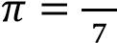

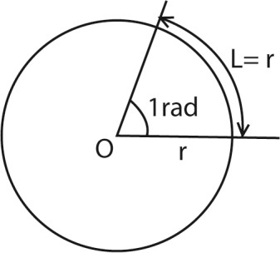

How to convert between degrees and radians
1 revolution = circumference of a circle
But circumference of a circle subtends an angle 2π at the centre.
⇨ 1 revolution = 2π = 360⁰ π = 180⁰ 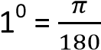 radians
x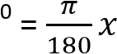 radians

Example 12
Convert the following angles to radians
- 330⁰
- 90⁰
- 30⁰
Solution
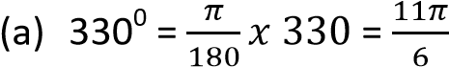radians 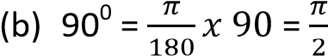radians 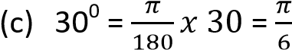radians
Converting radians to degrees
2π radians = 360⁰
1 radian = 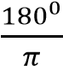
x radians =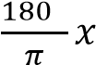

Example 13
Convert each of the following radians to degrees
- radians
- 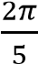 radians
(iii)  Solution | π radians
- radians = 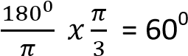
- 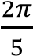 radians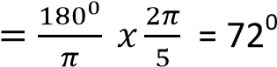
- π radians 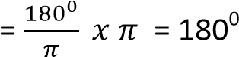

Some equivalent angles in degrees and radians


Example 1
4

90
0

=

𝜋

270
0

=

𝜋

180
0

=

𝜋

0
0

=

45
0

=
𝜋

315
0

=

𝜋

225
0

=

𝜋

135
0

=

𝜋

Find each of the following values
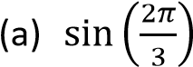
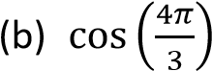
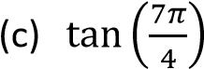
Solution
Convert the angles from radian to degrees
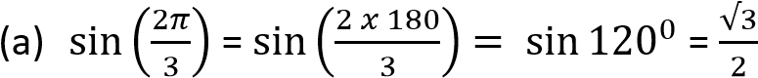
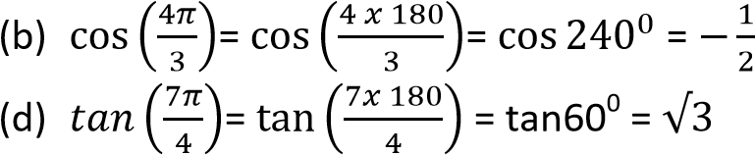

Compound angles
- cos (α + β) = cosαcosβ – sinαsinβ ⇨ cos2θ = cos²θ – sin²θ
- cos (α – β) = cosαcosβ + sinαsinβ ⇨ cos2θ = cos²θ + sin²θ
- sin (α + β) = sinαcosβ + sinβcosα ⇨ sin2θ = 2cosθsinθ
- sin (α - β) = sinαcosβ – sinβcosα
- tan (α + β) = 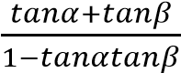
⇨ 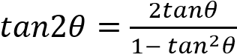
- tan (α -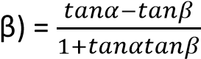

Example 15
Solve the equation cosθ = sin2θ for values of θ from 0⁰to 360⁰. (05 marks) cosθ = 2cosθsinθ cos(1-2sinθ) = 0
Either cosθ = 0 or θ= 90⁰, 270⁰
Or
1-2sinθ = 0 sinθ = ½ 0r θ = 30⁰, 150⁰ hence θ = 30⁰, 90⁰, 150⁰, 270⁰

Example 16
Show that cosec2θ + cot2θ = cotθ
Solution
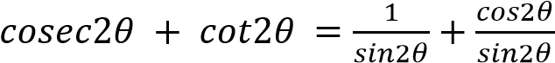
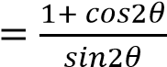
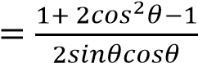
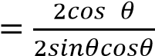
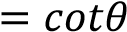

Example 17
If tanα = and α is acute, without using tables or calculator work out the value of
(a) tan2α
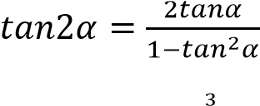
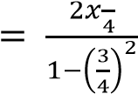
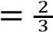
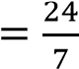
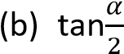
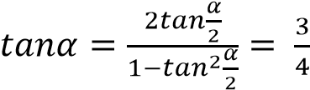
⇨ 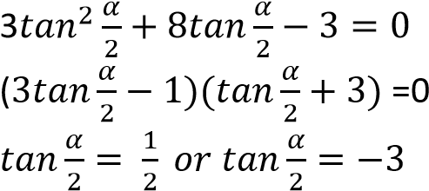

Since α is acute, tanα cannot be negative
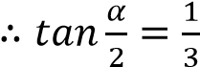

Example 18
Prove that cot 2θ = 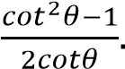 Hence solve the equation cot2θ + 2cotθ = 2 for 0⁰ ≤ θ ≤ 360⁰ Solution
cot 2θ = 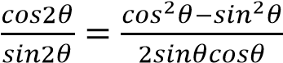
dividing through by sin² θ
cot 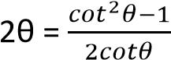
Hence, cot2θ + 2cotθ =0
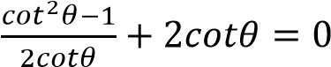
5cot²θ -4cotθ – 1 = 0
(5cotθ + 1)(cotθ -1) = 0 cotθ = 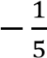 or cotθ = 0
⇨ tanθ = -5 ot tanθ = 1
When tanθ= -5; θ= 101.3⁰, 281.3⁰
When tanθ = 1, θ = 45⁰, 225⁰
{θ: θ= 45⁰, 101.3⁰, 225⁰, 281.3⁰}

Triangles
1. The cosine rule

)
a
(

Given an acute angle A

From triangle

h

D

A

B

C

a

b

c

x

c
-
x

ACD: x² + h² = b² ………………………...(i) BCD: (c – x)² + h² = a² c² – 2cx + x² + h² = a² …………… (ii) Substituting eqn. (i) into eqn. (ii) c² – 2cx + b² = a² But x = bcosA
⇨ b² + c² – 2bccosA = a²
a² = b² + c²-2bccosA (1)
Similarly;
b² = a² + c² – 2accosB (2) c² = a² + b² – 2abcosC (3)
It follows that
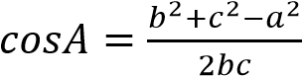
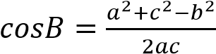
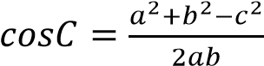

)
b
(

Given an obtuse angle A

In triangle ABC, A is an obtuse angle and CD is
(180
0
-

A)

b

a

c

x

A

B

C

D

h

A

the altitude.
From triangle
ACD: x² + h² = b² ………………………...(i) BCD: (c – x)² + h² = a² c² – 2cx + x² + h² = a² …………… (ii) Substituting eqn. (i) into eqn. (ii) c² – 2cx + b² = a² But
x = bcos (180⁰ – A) = -bccosA From triangle ACD
a² = b² + c²-2bccosA as before

The cosine rule can be derived using the vector approach.

A

B

C

a

b

c

Given a triangle above with BC = a, AC = c and
AB = b
BC = BA + AC = AC – AB a = b – c
⇨ a.a = (b – c)(b – c)
= b.b – 2b.c + c.c
= b.b + c.c – 2b.c a² = b² + c² – 2bccosA
since b.c = 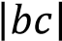cosA

Example 19
Solve the triangle in which AB = 6cm, BC = 4cm and angle ACB = 48⁰12’

Solution

A

B

C

4
cm

6
cm

48
0
12
’

Using: b² = a² + c² -2accosB
= 6² + 4² – 2(6)(4)cos48.2⁰ 1⁰ (degree) = 60’ (minutes) b = 4.47cm
Using: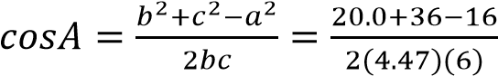
A =41.8⁰
But A + B + C = 180⁰
41.8⁰ + 48.2⁰ + C = 180⁰
C = 90⁰
AC = 4.47cm, angles BAC = 41.8⁰ and ACB
= 90⁰

Example 20
In a triangle ABC, prove that
(a) a² =(b – c)² + 4bcsin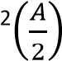 hence that a
= (b – c)secα where tanα = 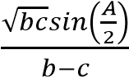
From cosA = 1-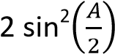
Substituting for cosA into the cosine formula a² = b² + c² – 2bccosA a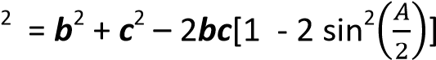 a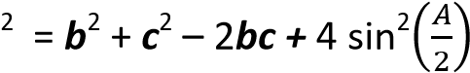
a² =(b – c)² + 4bcsin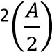
Hence, substituting for 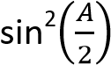into tanα expression we get a² = (b – c)² + (b – c)²tan² α a² = (b – c)²(1 + tan² α) a² = (b – c)²sec² α a = (b – c)secα


2.

The Sine Rule

The figure shows a circle
with centre O and
r

r

A

B

C

D

O

½ a

A

A

radius r circumscribing triangle ABC

Angle BOC = 2A [angle subtended by the same arc at the centre of the circle is twice the angle formed at any point on the circumference]
Triangle BOC is isosceles
OD bisects angle BOC and side BC
BD = ½a
From triangle BOD
sinA = 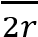 i.e. 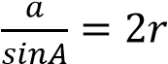
if instead we consider triangles AOC and AOB,
we obtain 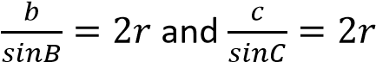
In general: 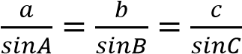

Example 21
Solve the triangle in which AB = 5cm, AC = 4cm and angle ACB = 60⁰
Solution


A

B

C

4
cm

5
cm

60
0

Using sine rule
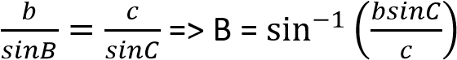
B = 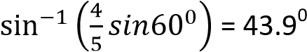
From A + B + C+ = 180⁰
A = (180 – 60 – 43.9)⁰ = 76.1⁰
Similarly a = 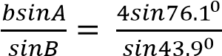= 5.6cm

Example 23
Prove that in any triangle
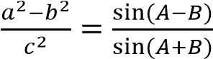
Solution
From sine rule formula; a = 2rsinA, b = 2rsinB, c = 2rsinC
By substitution
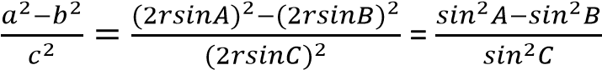
But A + B + C = 180⁰ C = 180⁰ – (A + B) sinC = sin[180⁰ – (A + B)] = sin (A + B) By substitution
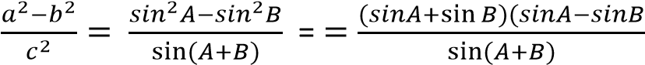
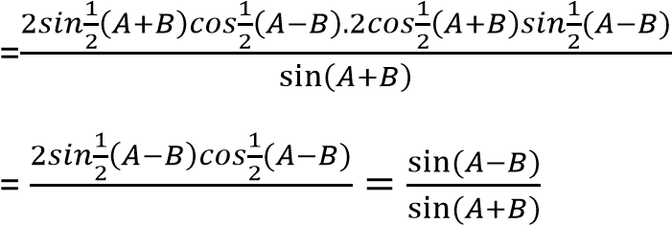
Hence 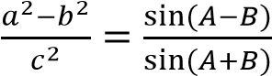
Example 24
Prove that in any triangle ABC,
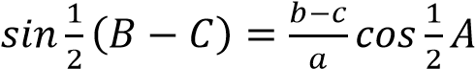
Solution
From sine rule formula; a = 2rsinA, b = 2rsinB, c = 2rsinC
By substitution
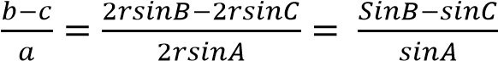
But A + B + C = 180⁰ A = 180⁰ – (B + C) sinA = sin[180⁰ – (B + C)] = sin(B + C)
By substitution
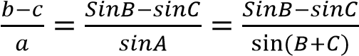
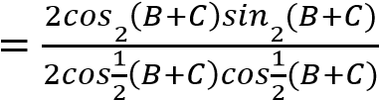
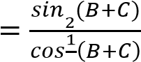
From A + B + C = 180⁰
B + C = 180⁰ – A
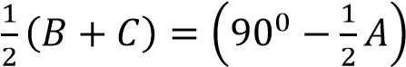

By substitution 